System Design and Architecture
The system architecture describes the different components that make up the CDSS system and the communication between them to provide a reliable diagnosis for the users, while ensuring that the user experience is seamless. As Figure 1.1 depicts, the system comprises five core components:
Patient Web Interface: This web interface is implemented in HTML/CSS and JavaScript. It is intended for the patient to answer initial questions and perform other tasks such as uploading documents, viewing appointments, and viewing their diagnosis.
Clinician Web Interface: This is a therapist-oriented web interface that the therapist can use to view the patient's responses, record even more questions, add test and observation results, and perform other administrative tasks such as appointment management, document requests, etc.
Backend Module: This is implemented using TypeScript, a Microsoft-backed variant of the JavaScript programming language. It integrates with both interfaces mentioned above, stores the recorded data, and presents it in an easily consumable format. It also applies rules-based heuristics to the recorded responses to provide a temporal diagnosis.
SQL Database: The database component is a PostgreSQL database that stores the data securely in a format that the backend can efficiently retrieve and the Python-based machine learning modules can use.
Machine Learning Model: This Python-based machine learning model uses Bayesian Neural Networks to provide a more refined final diagnosis. This module uses data obtained from the patient responses, the clinician responses, and the results of the different tests and observations.

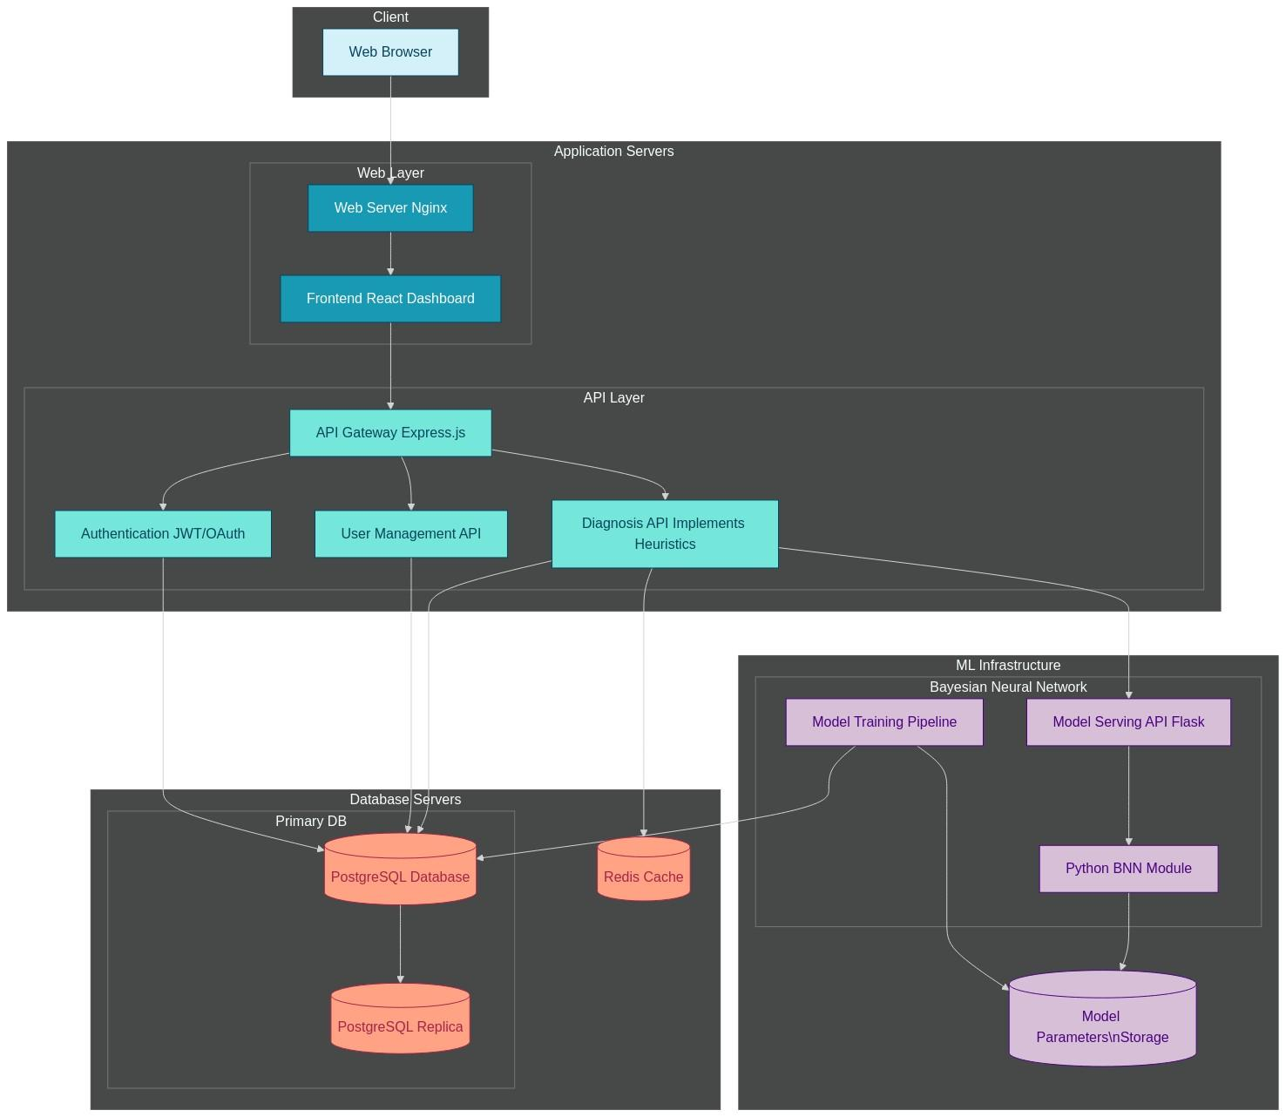
Figure 1.1: System architecture showing the various components of the CDSS system.

Sequence Diagrams
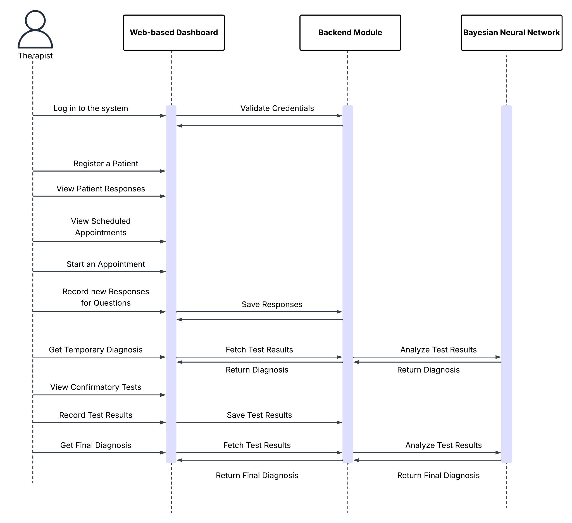
Figure 1.2: Sequence diagram for the therapist

Database Design
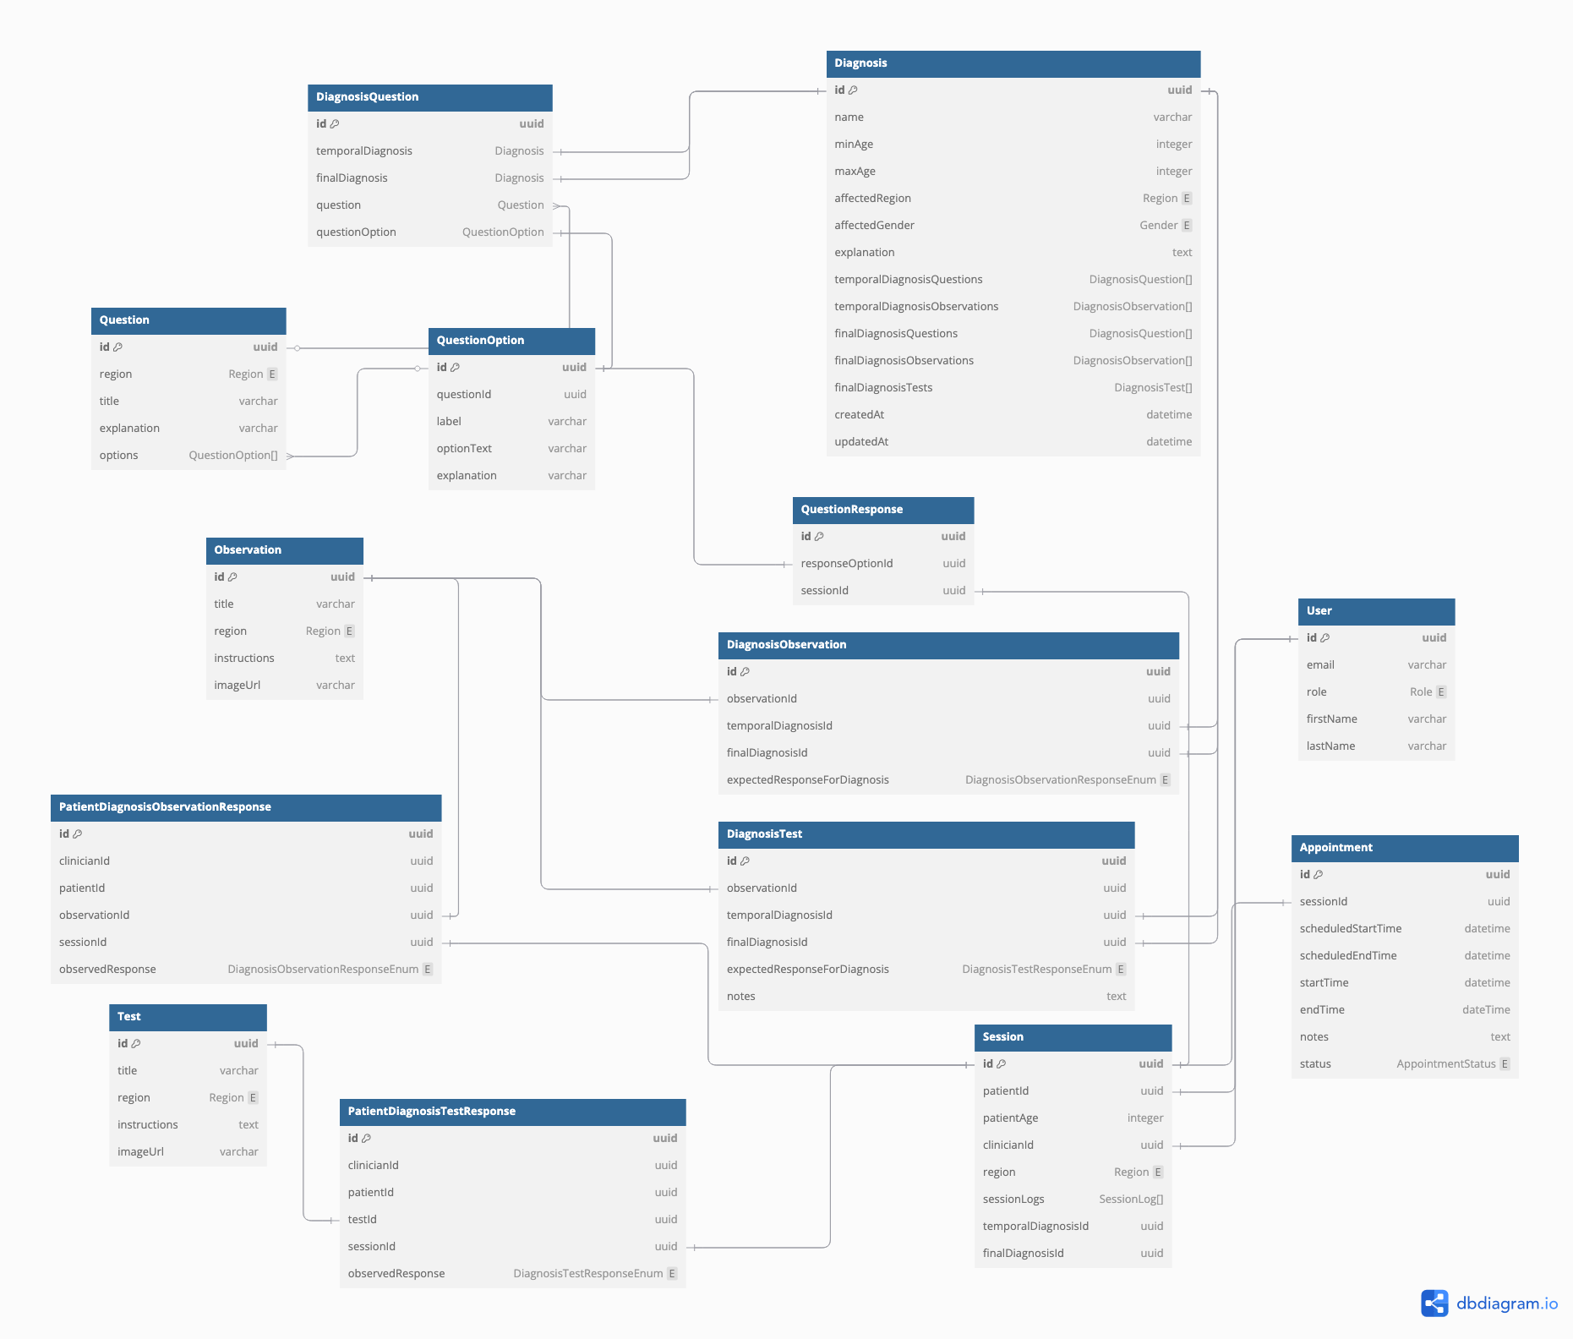
Figure 1.4: Entity-Relationship diagram showing the database structure of the system.

Core Diagnosis Algorithm
The system uses a combination of rules-based heuristics and a Bayesian Neural Network to form a diagnosis.

The initial temporal diagnosis uses rules-based heuristics based on the available information (such as patient and therapist responses to the questions asked, recorded observations, and test results, if available).

The final diagnosis is a more refined diagnosis that uses a Python-based Bayesian Neural Network as its basis. This diagnosis requires observations and test results to be available (as opposed to the temporal diagnosis, for which these are optional). The network uses all the recorded responses and these results as input variables.

The diagnostic algorithm operates on a weighted matching paradigm where patient responses to diagnostic questions are compared against expected response patterns for various conditions. This approach aligns with Bayesian inference models in medical diagnosis, where observed symptoms increase or decrease the likelihood of specific conditions. Additionally, the system prioritizes the diagnosis that explains the most reported symptoms rather than requiring a perfect match of all criteria.

The diagnostic matching process implicitly generates a confidence metric, as diagnoses with a higher ratio of matched questions to total diagnostic criteria can be considered more probable. This provides a quantifiable measure of diagnostic certainty that could be valuable for clinical decision-making.

More theoretically, the heuristic for the rule-based diagnosis can be formalized as follows:

For a given patient session _S_ with responses _R_ = {r₁, r₂, ..., rₙ} and a set of possible diagnoses _D_ = {d₁, d₂, ..., dₘ}, each diagnosis dᵢ is associated with a set of expected question-response pairs _Q_dᵢ_ = {(q₁, a₁), (q₂, a₂), ..., (qₖ, aₖ)}.

The algorithm selects the diagnosis _d_* that maximizes:

d* = max{d ∈ D} |{(q, r) ∈ R | (q, r) ∈ Q_d}| / |Q_d|

This represents a form of maximum likelihood estimation where the probability of a diagnosis is proportional to the percentage of matched diagnostic criteria, with each parameter explained as follows:

- d* is the selected diagnosis (the diagnosis the system ultimately chooses)
- max{d ∈ D} is a function whose goal is to "find the diagnosis d from the set of all diagnoses D that maximizes the following value"
- |{(q, r) ∈ R | (q, r) ∈ Q_d}| counts how many of the patient's question-response pairs match the expected responses for a given diagnosis
- |Q_d| is the total number of diagnostic questions for that diagnosis
- The division creates a ratio of matched responses to total questions.

Tools for System Development
Table 4.1: Development tools used in the development of the VOC-M system.
Type of Development Tool | Tool(s) used | Description
Integrated Development Environment (IDE) | WebStorm | WebStorm is an Integrated Development Environment developed by JetBrains. It supports both the JavaScript programming language and its TypeScript variant. It also has excellent built-in database management support, which this project also uses.
Programming Language | TypeScript | TypeScript is a variant of the JavaScript programming language developed by Microsoft. It provides static type definitions and advanced Object-Oriented features on top of JavaScript, making it a perfect candidate for the CDSS implementation.
Database | PostgreSQL | PostgreSQL (often called "Postgres") is an open-source object-relational database system emphasizing extensibility, standards compliance, and reliability. It provides robust data integrity, allowing users to safely store and retrieve complex data structures.  Key features of PostgreSQL include:  - ACID compliance: Ensures transactions are processed reliably with Atomicity, Consistency, Isolation, and Durability.  - JSON support: Handles JSON data with specialized operators and functions for flexible schema designs.  - Extensibility: Allows creation of custom data types, operators, and functions to suit specific application needs.  - Concurrency control: Implements multi-version concurrency control (MVCC) for efficiently handling simultaneous operations.  - Robust security: Provides role-based access control, column/row-level security, and encryption options.
Version Control System | Git | Git is a distributed version control system that tracks changes in code repositories. It allows developers to maintain multiple versions of projects, collaborate seamlessly, and quickly revert to previous states if needed.
Web Development | HTML  CSS  Next.JS | HTML (Hypertext Markup Language) is the standard language for creating web pages. CSS (Cascading Style Sheets) describes how a document written in HTML is presented, controlling layout, colors, and fonts.  Next.js on the other hand is a React framework for building JavaScript applications. It offers server-side rendering, static site generation, and other performance optimizations out of the box. Together, these three technologies power the clinician dashboard.
Cloud Services | Cloudflare R2  Fly.io  Amazon Relational Database Service (RDS). | R2 is an object storage system developed by Cloudflare. For this project, it hosts the various media used by the system, such as icons of musculoskeletal parts, example images of confirmatory tests, files uploaded by patients, etc.  For this project, RDS was chosen because it is cheaper than industry alternatives such as Amazon’s S3 and Google Cloud Storage.  Fly.io is a platform for running full-stack apps and databases close to users. The CDSS system's frontend and backend modules are deployed on Fly.  Amazon Relational Database Service (RDS) is a cloud database service offered by Amazon. The CDSS uses the free tier to host the SQL database powering it.
Testing Framework |  | The Jest testing package supports automated testing of JavaScript and TypeScript packages. The system uses this package to perform unit testing of submodules, ensuring better correctness and reliability.
Diagramming Tools | DbDiagram  Diagrams.net | DbDiagram is an online tool that converts a given database schema/structure to its corresponding Entity-Relationship Diagram. It features generating these diagrams via code for ease of editing and flexibility.  Diagrams.net is an online editor that generates several engineering diagrams, such as sequence diagrams, use-case diagrams, etc.

